**Appendix 2: Other Prototype Iterations**

The way we have decided to go about in developing initial drafts of the prototype was for each member of the team to go and create prototypes centered around the tasks we have collected. This way we would have many diverse prototypes to choose from. Although, since each prototypes is built around a certain task rather than the overall system requirements, each prototype is rather incomplete. For example, we would run into problems doing a walkthrough of task 7 with prototype 3 even though prototype 3 works well with task 3. The idea of our approach was to choose one of the many prototypes we liked conceptually and then build on top of that one by implementing design choices of the other prototypes. Specifically, we’d implement other design choices to the chosen prototype that covers a specific system requirement. One problem we’d run into often is trying to implement specific design choices of one prototype into the chosen prototype, as often time they would conflict with each other. Below are the iterations of other prototypes and early drafts that we did not decide to build upon.

Physical copies of the prototypes can be found at the back of this section in the order presented here.

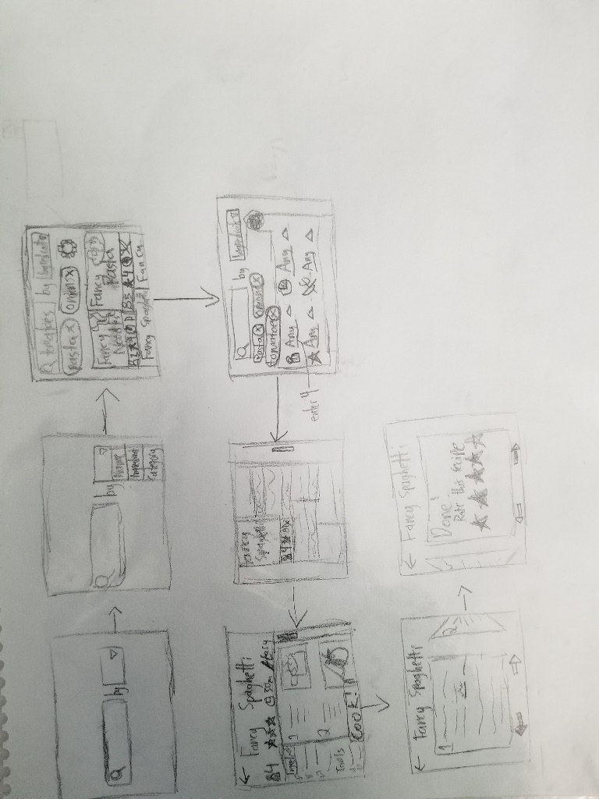 Prototype 1

Prototype 1 was designed around task 1 which includes the system requirements to search for recipes depending on ingredients, following instructions to completion of the dish and then rating the recipe. One feature that we decided to implement into our final prototype was the search by ingredient function which turns ingredients typed into tags.

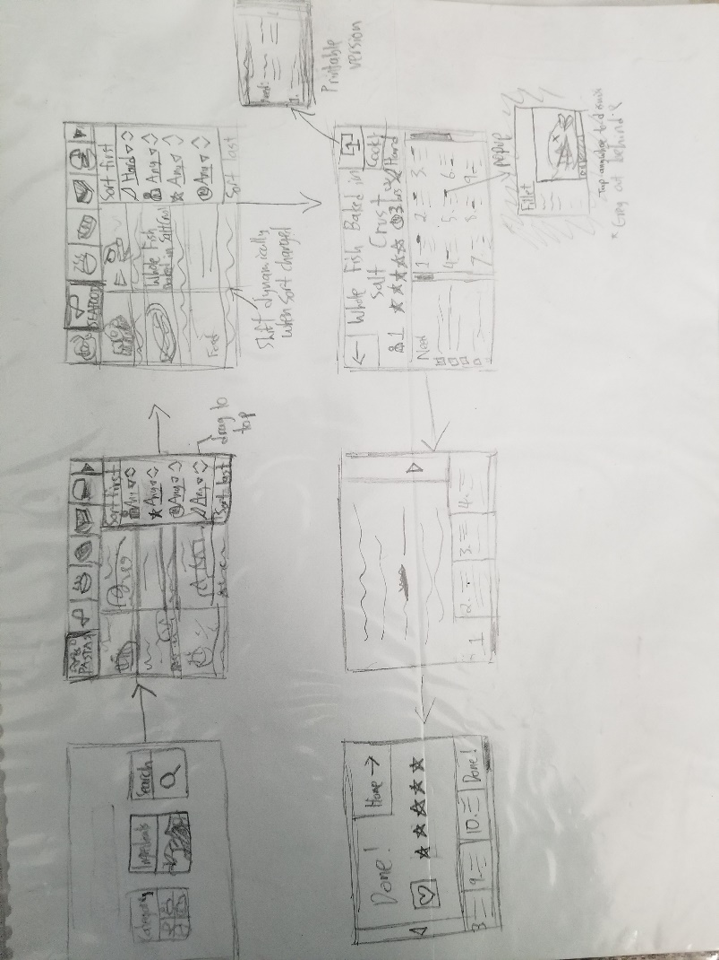

Prototype 2

Prototype 2 was centered around task 2 which included the user searching a recipe depending on difficulty and ingredient number, learning cooking terminology, printing the recipe (in which we consider downloading the recipe sufficient enough). We decided not to follow up on this because the screen to search seems overly complex and may overwhelm the user. We did implement the category bar on the search screen because it is simple, appealing and does not take much space.

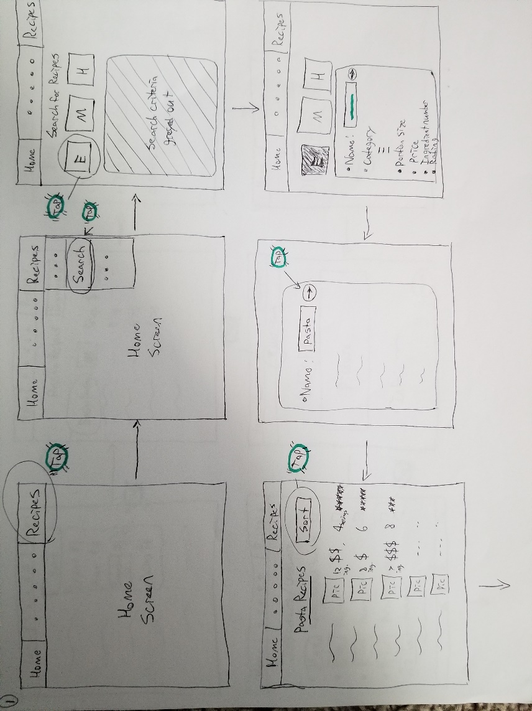Prototype 3 Version 1

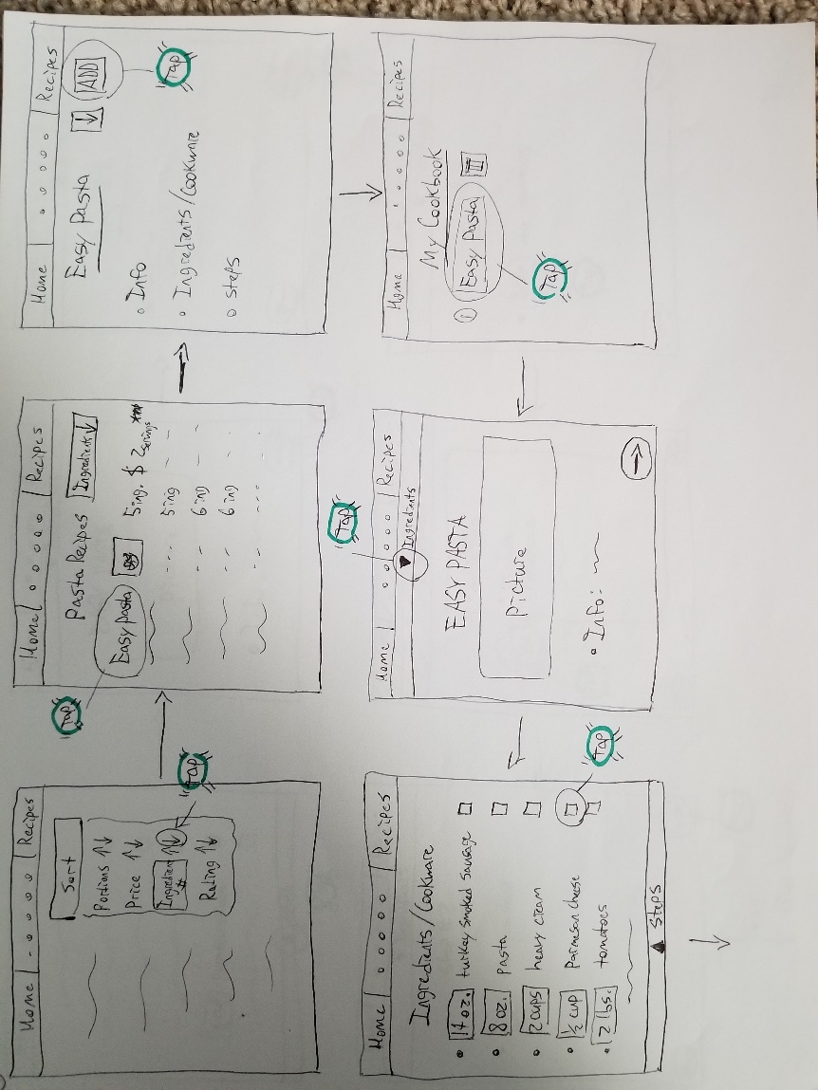

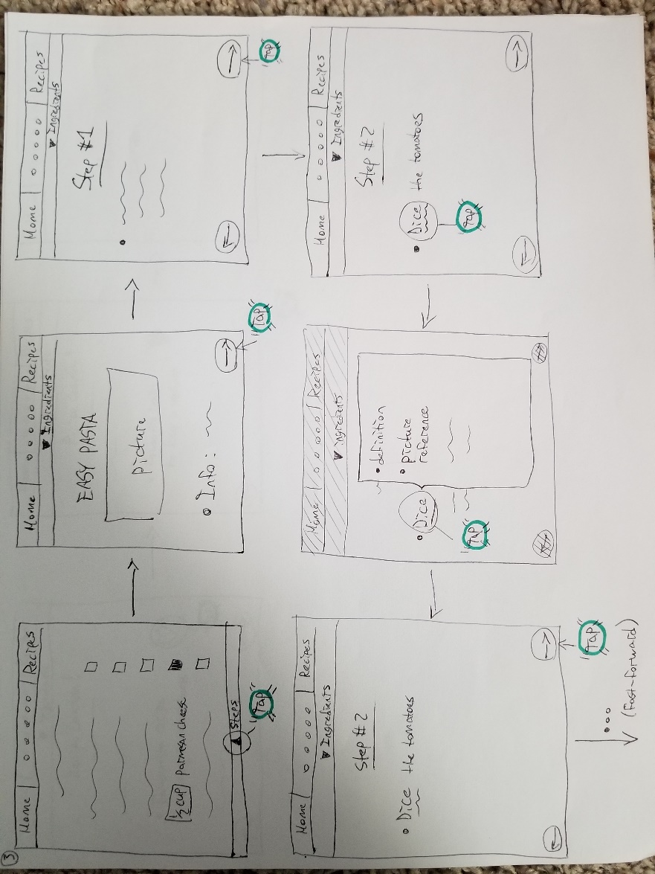

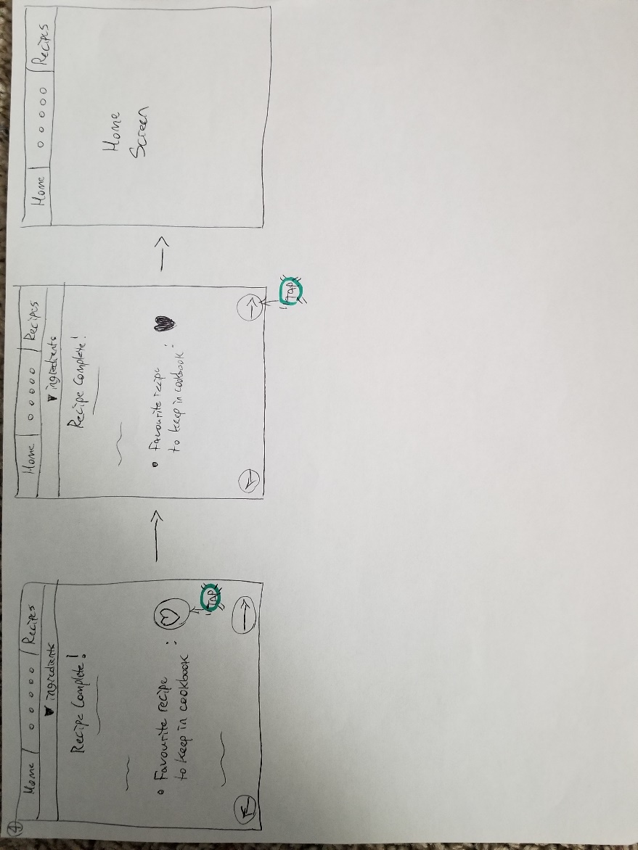

Prototype 3 version 1 centered around task 3 which required various tasks from the user; search for a dish, aquire a shopping for ingredients, following instructions to completion, learning terminology and saving the receipe. We decided not to to follow up on this prototype because it requires a lot of navigation (search for recipe, click on recipe, add recipe to cookbook, finally get into the recipe profile page from cookbook).

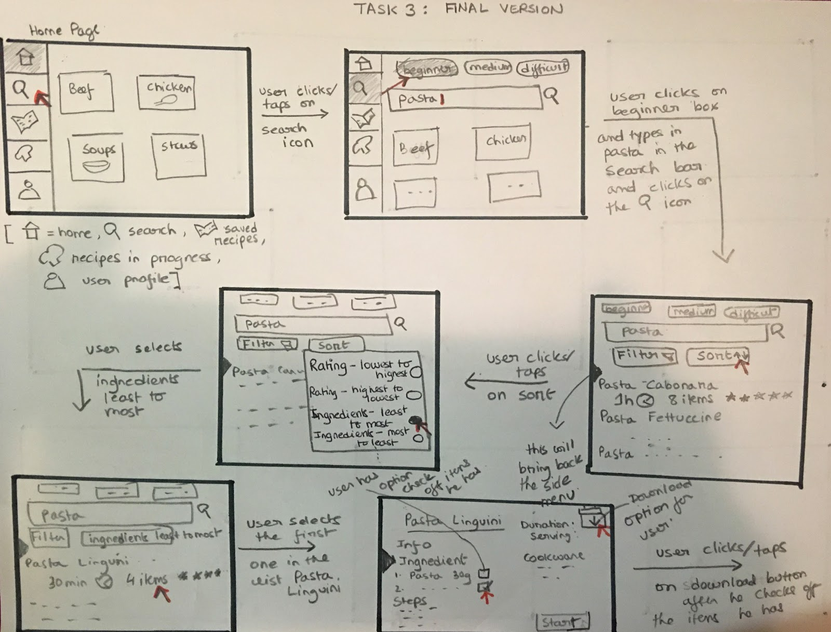Prototype 3 Version 2

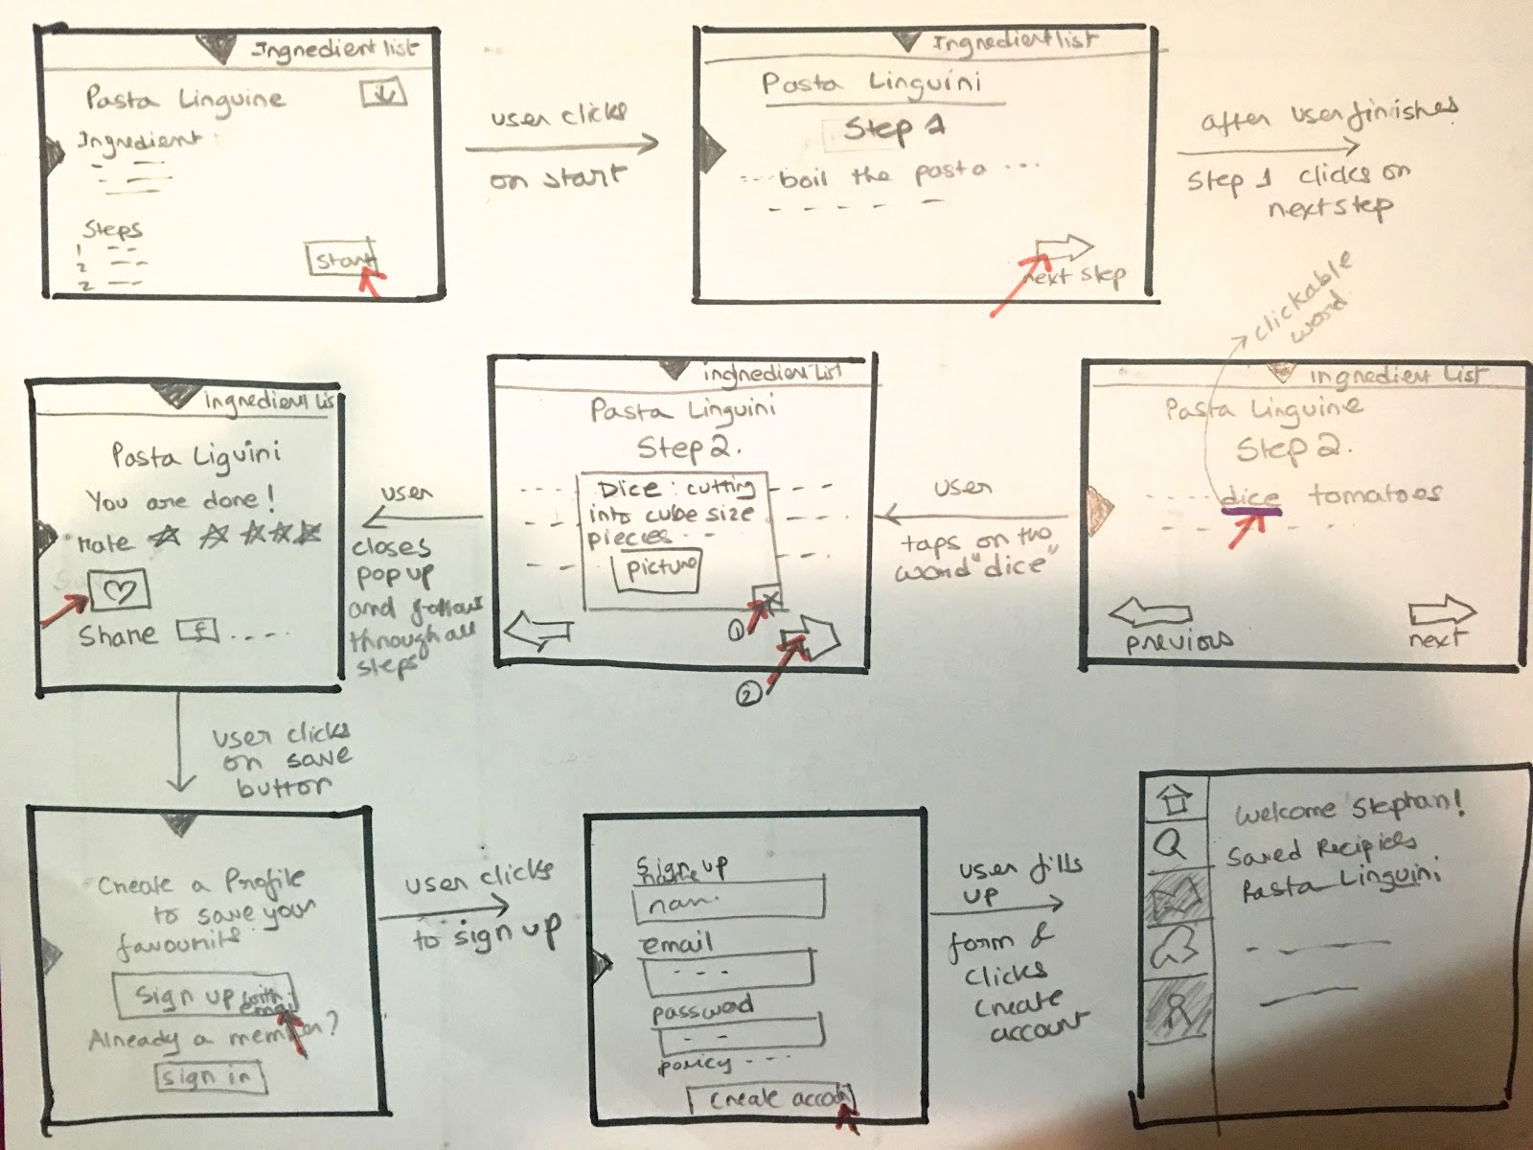

Prototype 3 version 2 centered around task 3 which has been explained already above. This is the version we have built upon to completion of our final iteration. We agreed as a team that this interface was simple, easy to navigate and easy to understand. This is also the prototype that we have decided to show during the presentation. This prototype was built later, after the earlier prototypes were made, so you may notice some features of other interfaces on here.

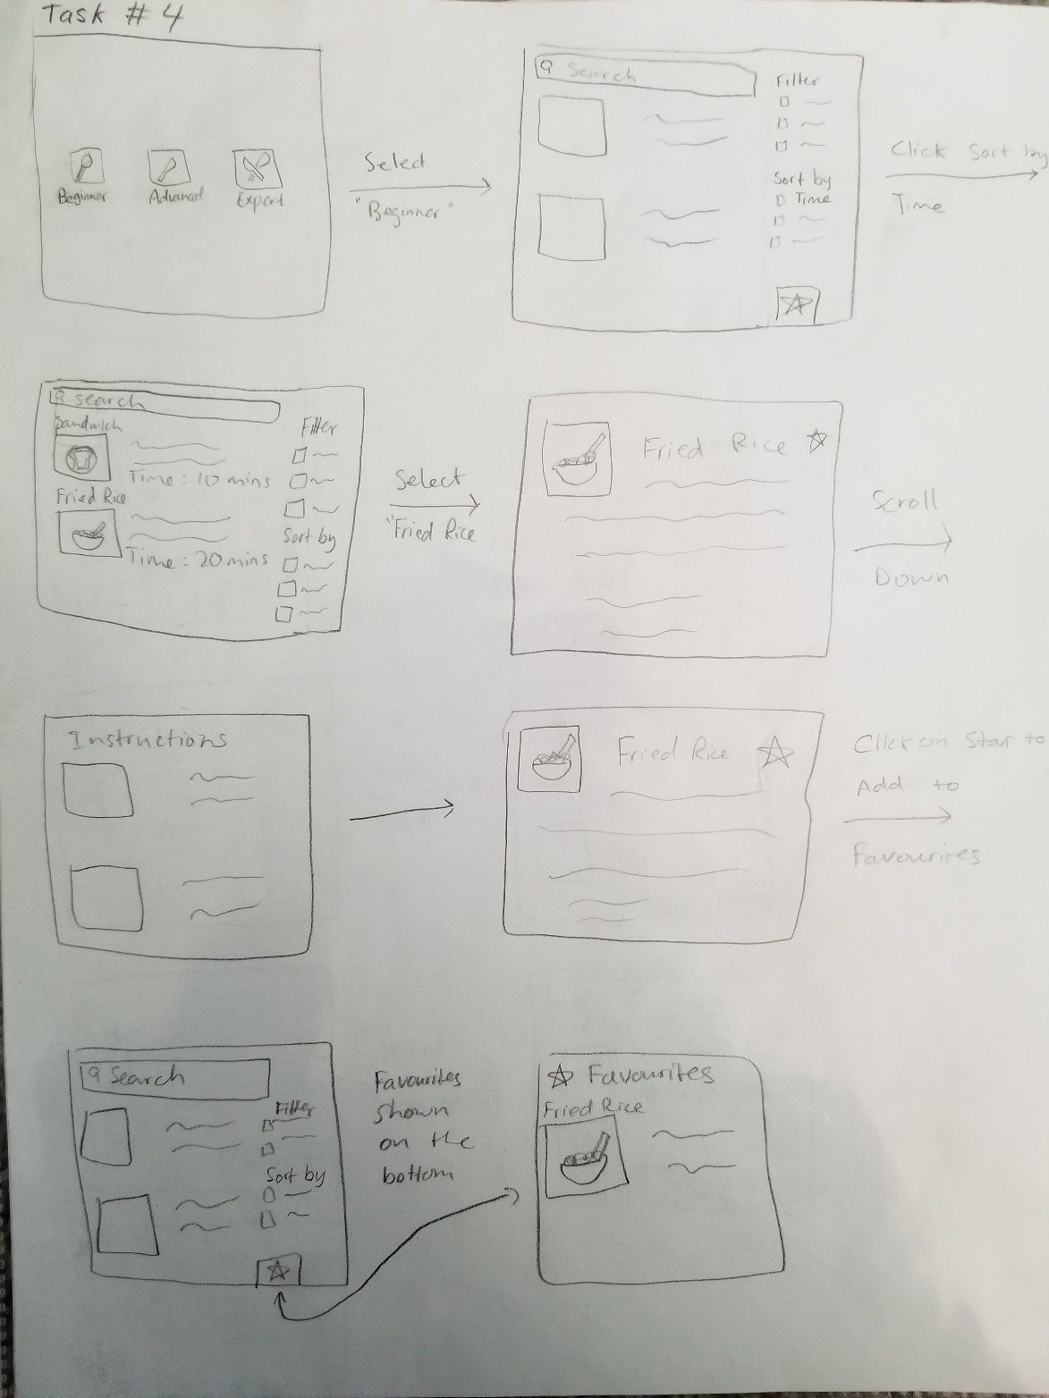Prototype 4

Prototype 4 centered around task 4 which included the tasks of searching recipes by duration and duration only, seeing the recipe to completion and then saving the recipe for later. We didn’t implement this because we didn’t know how we can show a list of items without having searched for anything yet. If it showed everything in the database and imagine the database to be large, then it would group all recipes that are 5 minutes, then all recipes that are 10 minutes and then 20 minutes. You would have to scroll a lot before you reach a recipe that is 20 minutes. To save clutter, we have decided not to follow up on this idea.

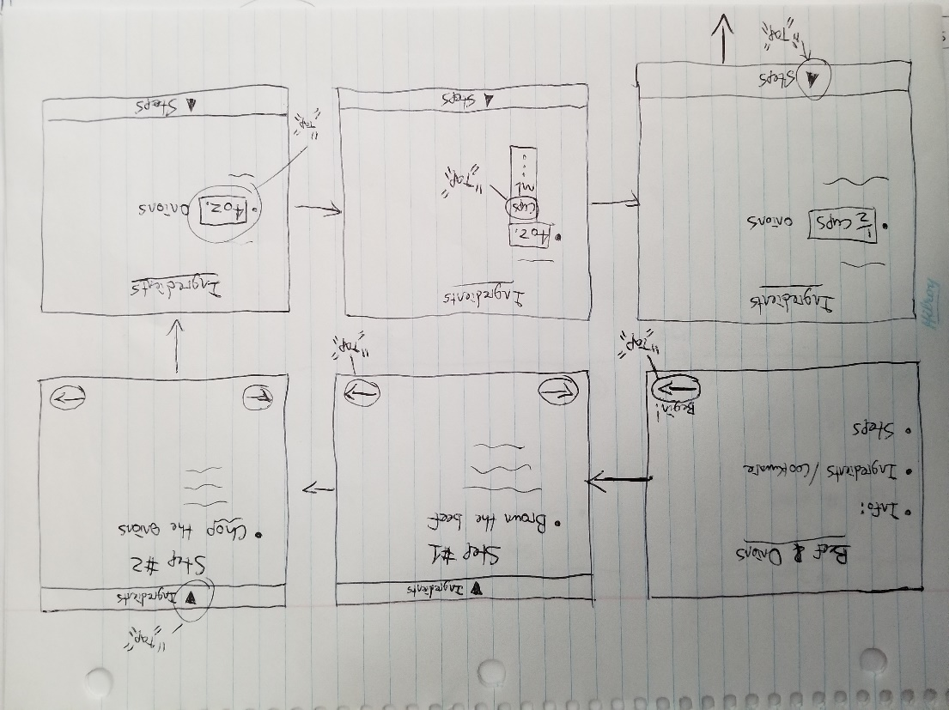Prototype 5

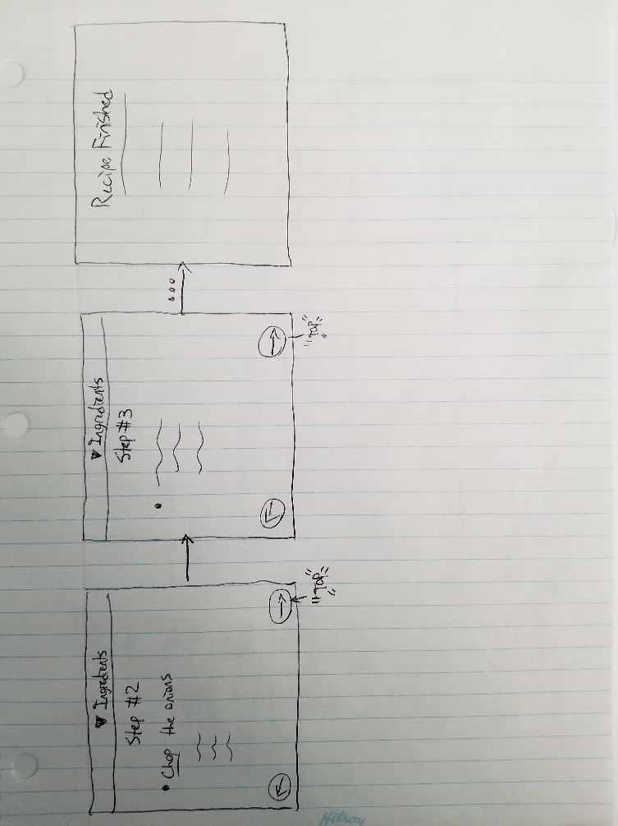

Prototype 5 was built around task 5 which included the user to go through step by step through the recipe as well as converting measurement units to his preferred measuring units. This prototype lacked core menus such as the main menu so we decided not to build on top of this one. Although we did implement the step by step instructions as it seemed interactive and engaging.

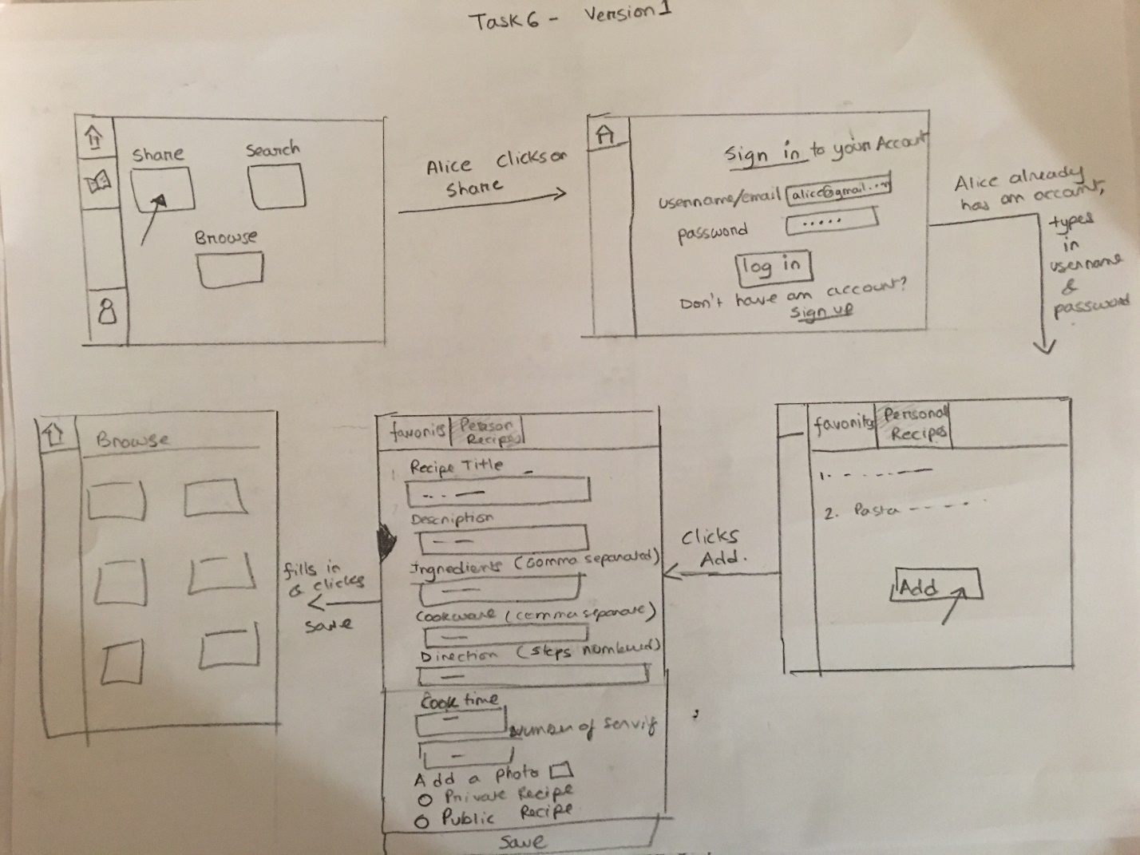Prototype 6

Prototype 6 was made around task 6 which included a situation that had someone making their own recipes and using the sharing function. We implemented the side bar from this prototype into the finalized prototype.

Prototype 7 Version 1

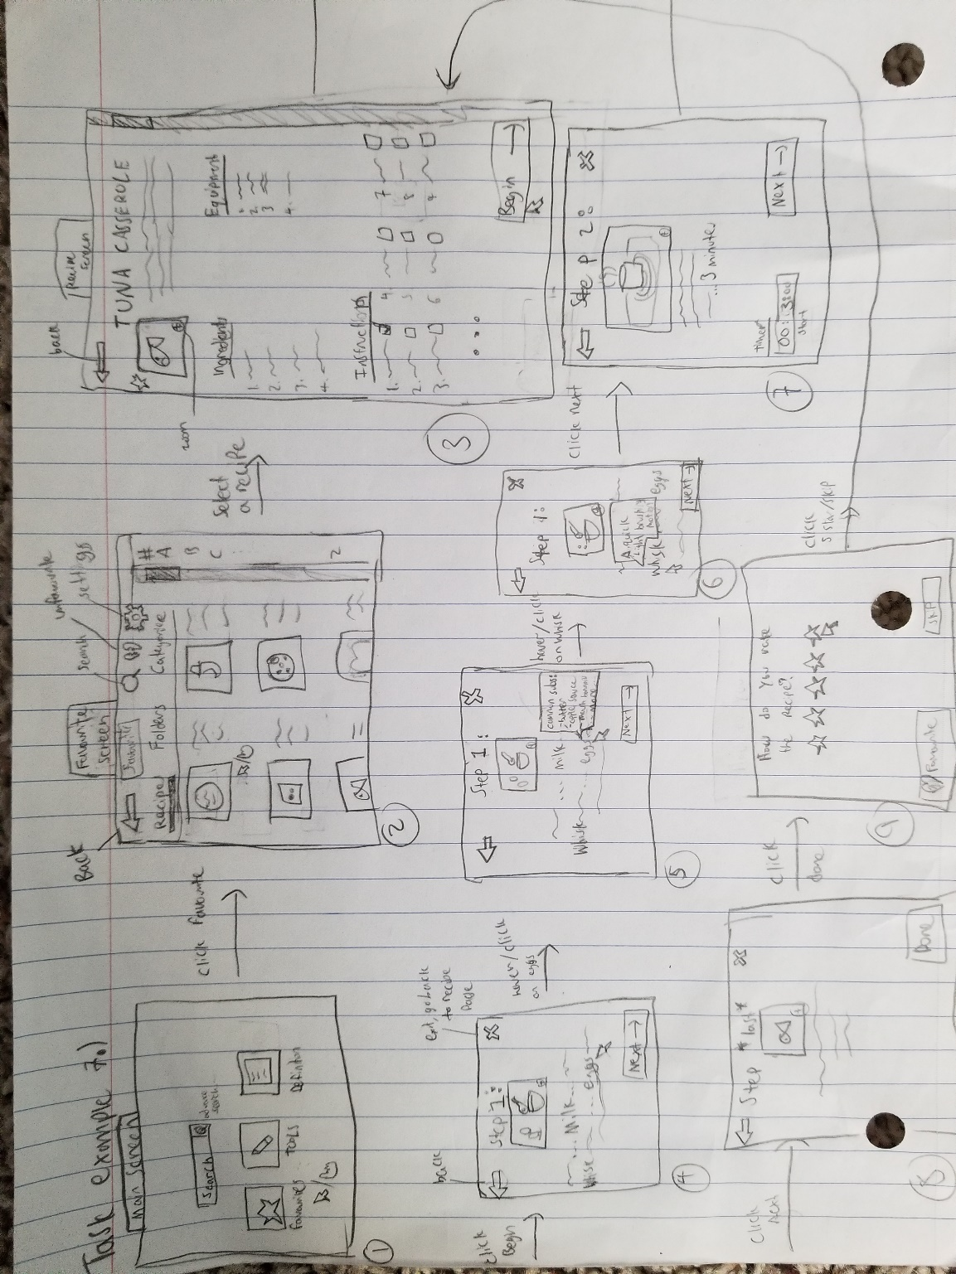

Prototype 7 version 1 built upon task 7, which has changed after this prototype was made. Jump to Prototype 7, version 2 which reflects the change of the task example.

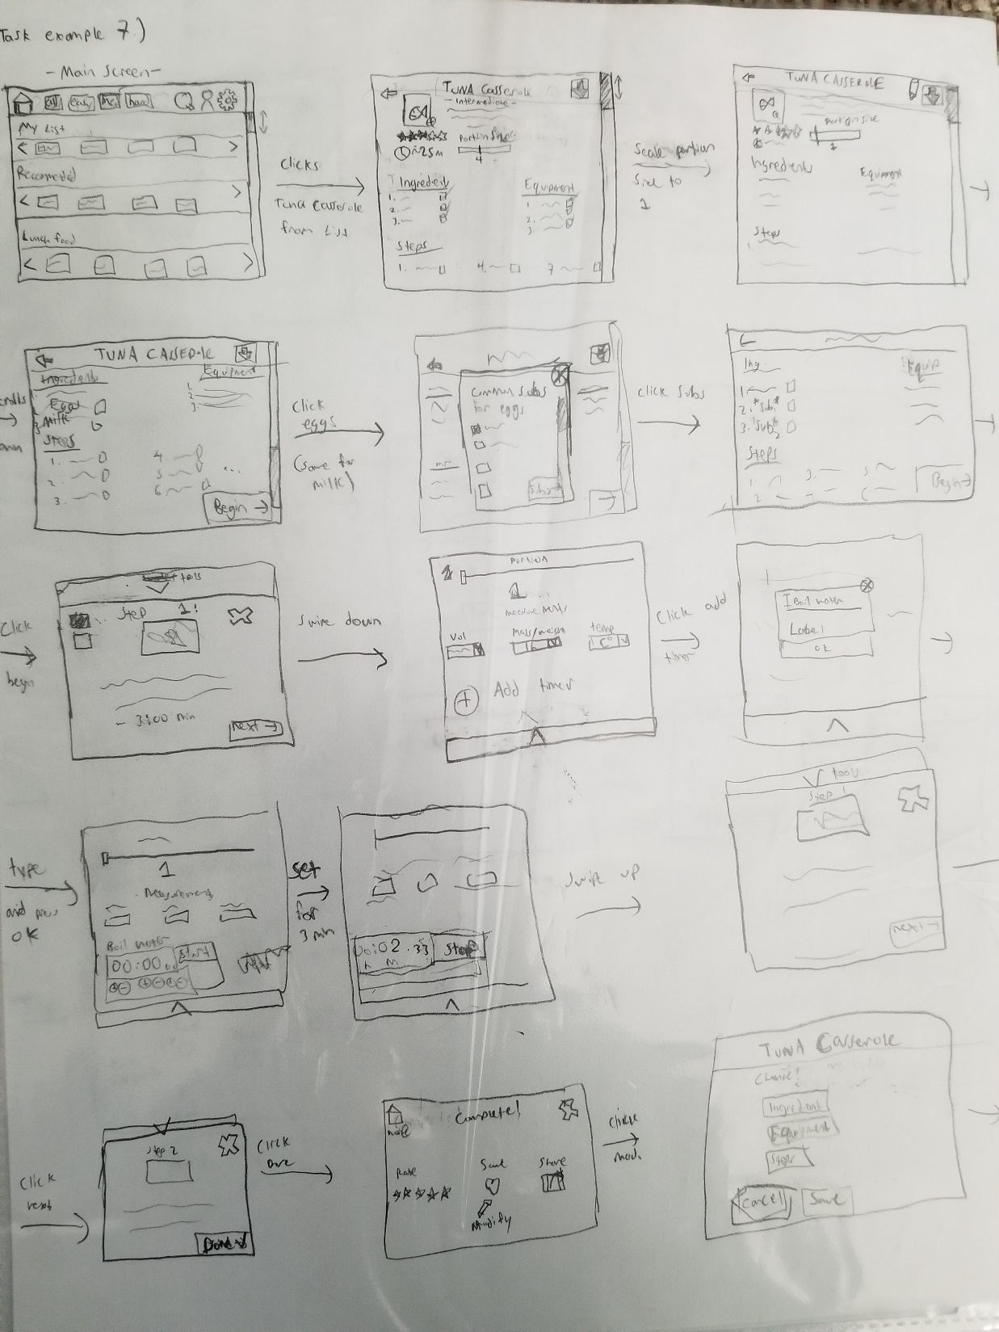Prototype 7 Version 2

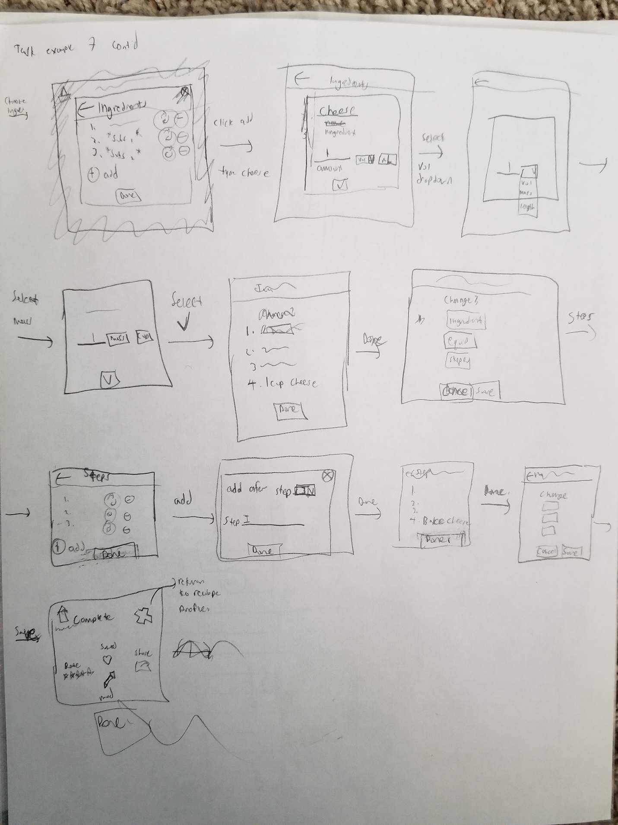Prototype 7 Version 2 built around task 7 which included tasks such as accessing her favourite meal, scaling portion sizes, following instructions, substituting ingredients, using a timer as well as modifying a recipe. This task had the majority of complicated, fairly rare tasks that are not present in the rest of the other tasks examples. Such as using a timer, modifying a recipe, scaling portion sizes and substituting ingredients. Naturally, this prototype would have a lot of features not yet implemented in other prototypes and so things such as timer, scaling portion sizes, ability to edit recipes and substituting ingredients were implemented in some way.